**Second highest salary**

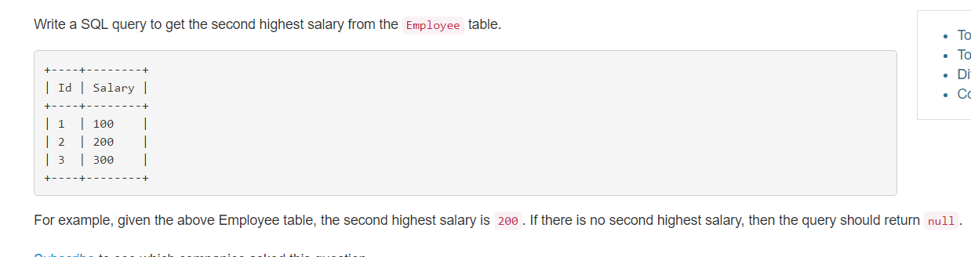

* select max(Salary) as 'SecondHighestSalary'

From Employee

Where Salary < (select max (Salary) from Employee);